Fake News Detection Using Machine Learning

Data Classification - R

Group Info:

- Zaheer Hussain - 22XV1M6719
- R. Havish -22XV1M6725
- Harshith Raj - 22XV1M6726
- Owais -22XV1M6713
- Azhar -22XV1M6706

Date of Submission:

Summary:

Dataset Overview:
The dataset comprises 21,000 news articles labeled as either fake or real, making it an ideal resource for fake news detection tasks. The data includes crucial features such as the title, author, and text of each article, along with a binary label indicating its authenticity (1 for fake news and 0 for real news).
The news articles are sourced from various online platforms, reflecting a mix of truthful reporting and misleading content. The dataset is structured to facilitate text classification problems, where machine learning and natural language processing (NLP) techniques can be applied to determine the credibility of a given news article.

Key Features:
- id: Unique identifier for each article.
- title: The headline or title of the news article.
- text: The main body/content of the article.
- label: Target variable (1 = Fake, 0 = Real).

Introduction:

Purpose:
- To analyze and preprocess a fake news dataset.
- To build machine learning models that can accurately classify news articles as fake or real.
- To compare the performance of different machine learning algorithms.
- To provide recommendations for improving the system's accuracy and efficiency.
Description:
The spread of fake news has become easier in the digital age, as social media platforms and other online channels allow anyone to create and share content with the world.
The problem with fake news is that it can be very convincing, and people may believe it to be true without questioning its authenticity. This can lead to a range of negative consequences, That is why a sophisticated method is required to identify fake news
Source:
The dataset is the WELFAKE Dataset
Tools Used:
- R- For data Visualization.
- ChatGPT – For debugging and to understand unknown concepts encountered while analyzing the dataset.
Getting to Know About the Data:

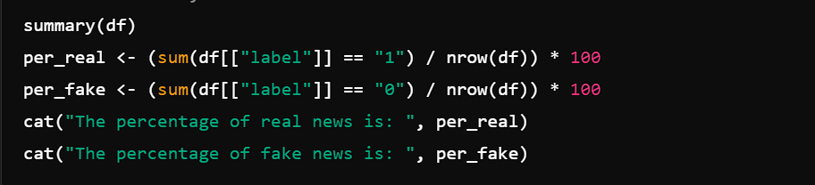

Summary:
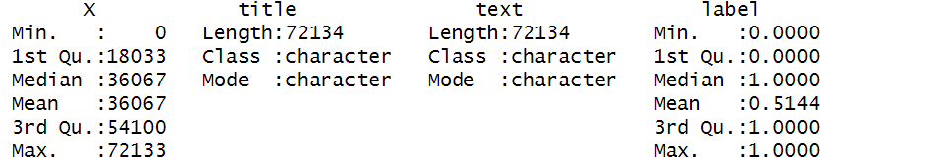

Label Distribution:

Type | Real | Fake
Percentage | 51.44 | 48.55

Data Cleaning:
- Column Selection and Filtering:
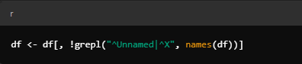
The Dataset came with an Unnamed Column which contained the record numbers which was not useful part of the dataset since Data frame already comes with the row number, Hence the column is dropped.
- Count NA Values in Each Column:
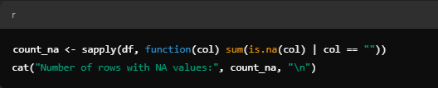
Column | Title | Text | Label
Missing Values | 558 | 39 | 0

- Create a DataFrame with NA Counts:
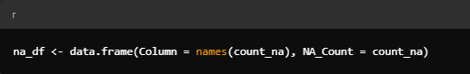
Converts the count_na vector into a dataframe.

- Visualize Missing Values Using a Bar Plot:
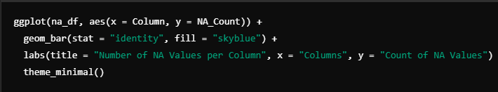
Plots the number of missing values (NA or " ") for each column using ggplot2.

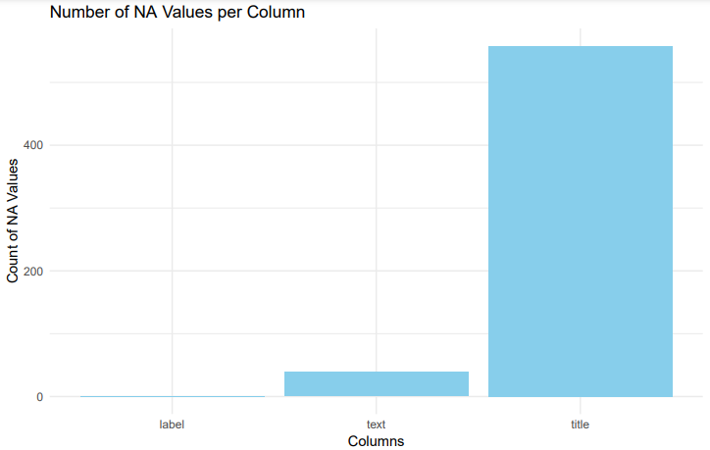

- Remove Rows with Empty Strings:
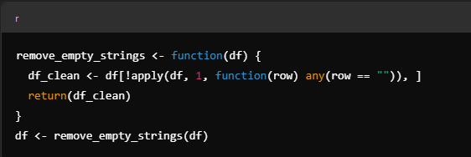
Removes rows containing any empty strings (" ").

Data Preparation:

Combining both the titles and texts associated with the news into a new column.
Calculating the length of the words present in the “text+title” column excluding the spaces.

Exploratory Data Analysis:

Body Length Distribution plot:
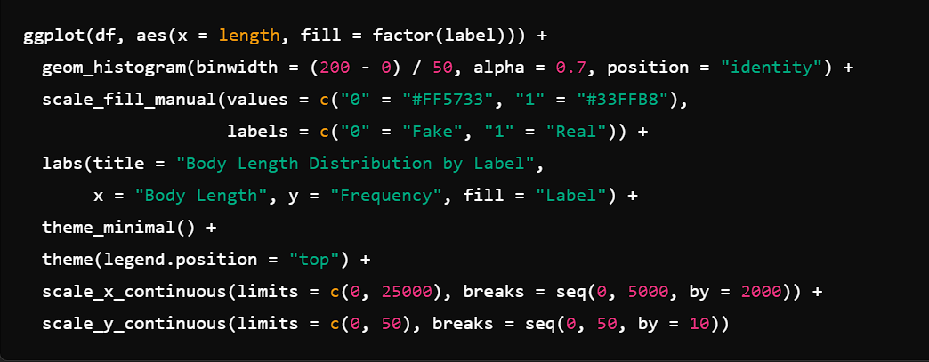
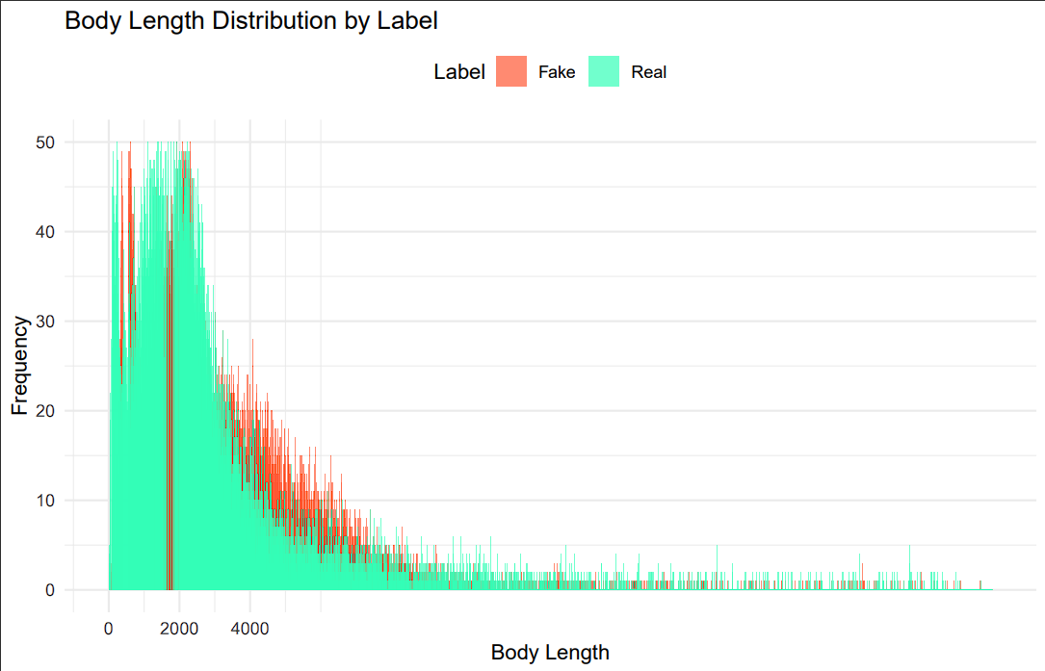

The plot gives us an overview of the body length of real and fake news and due to the higher density in the plot its difficult to give any insights, so let’s take a closer look into the distribution.

Closer Look into the Body Length Distribution:

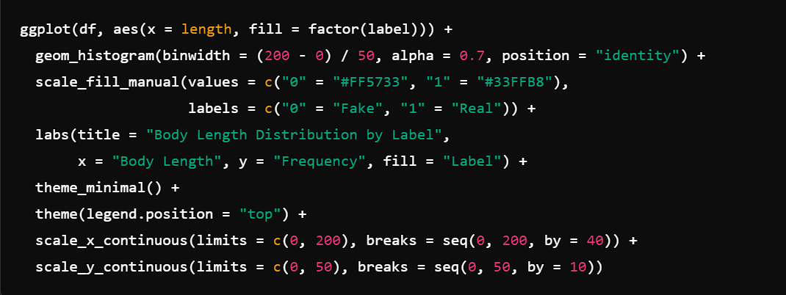
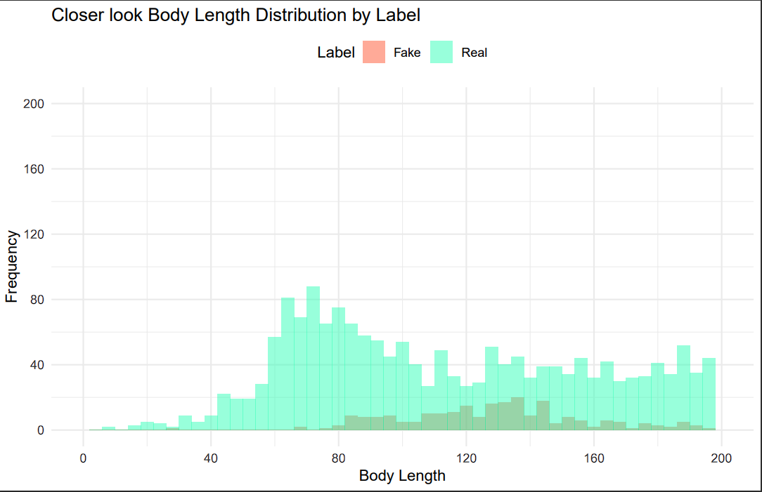
From the distribution we can deduce that the Body Length of the real news is greater than that of fake news.

Number of Fake and Real News Bar Plot:

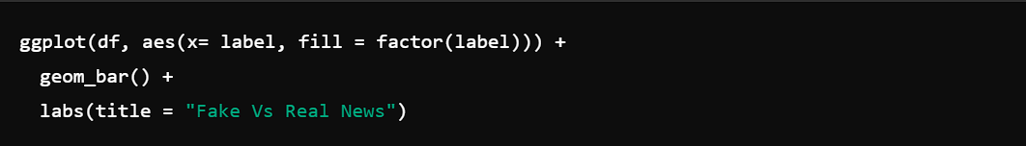

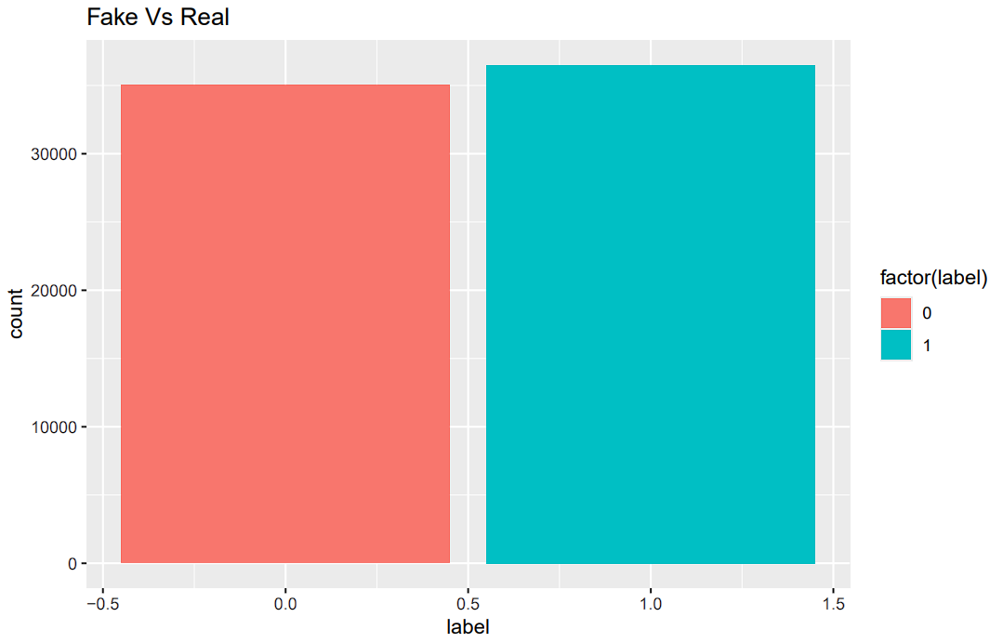

The plot gives us an overview of the number of fake and real news records present in the data after cleaning.
All the Title’s Word Cloud:

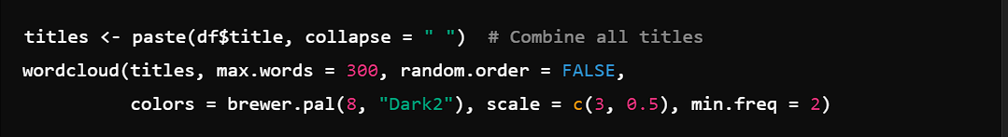

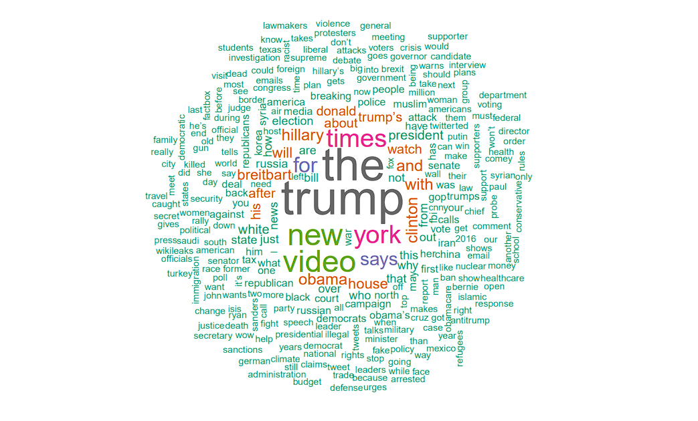

Insights:
- Many of available news articles are about elections and presidents of USA

Data Visualization of texts in Fake and Real News:

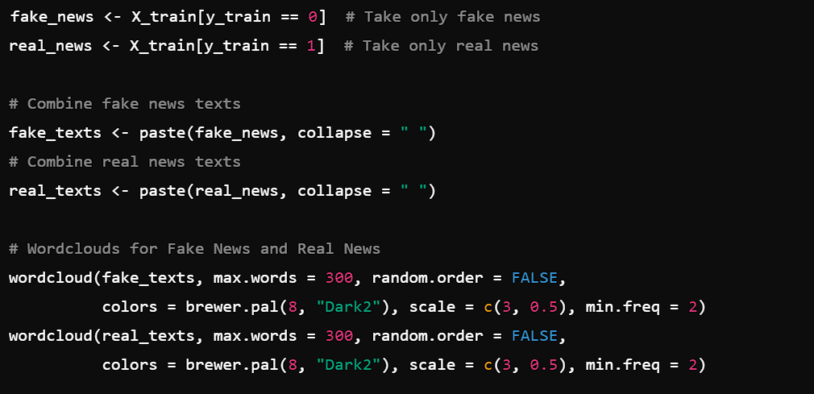
Fake News:
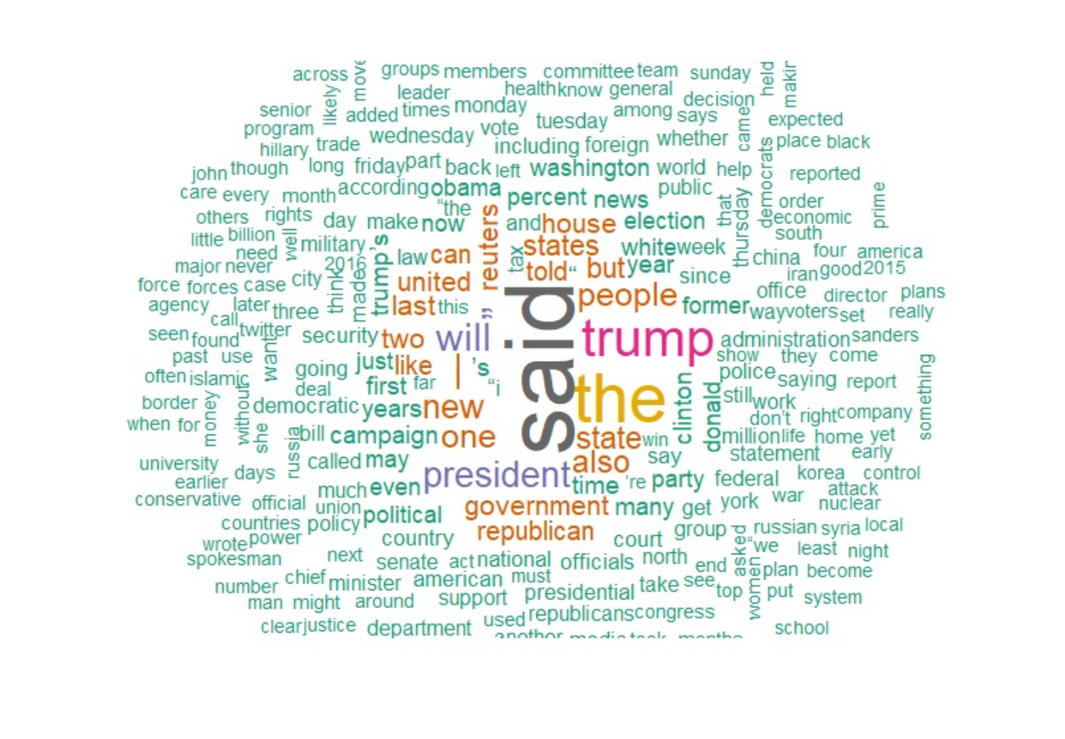
Real News:
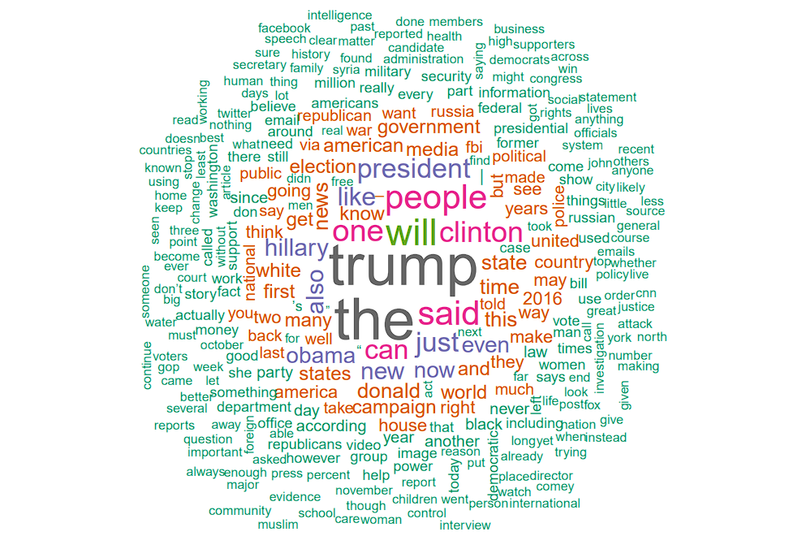

Test and Train Split:
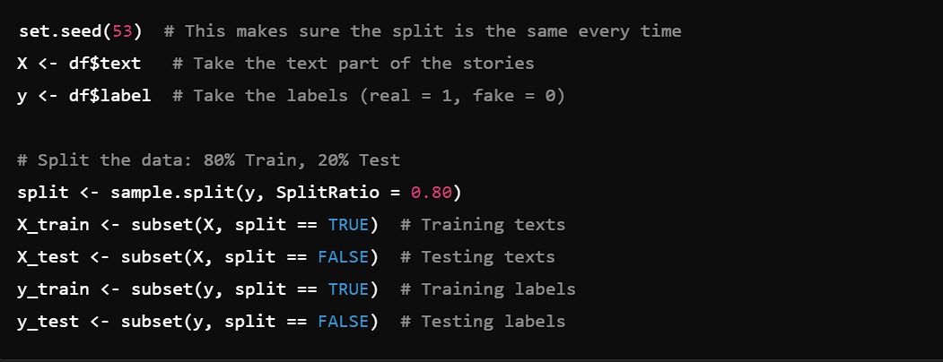
Using a 80-20 split .
Preprocessing the Data:
Steps Involved:
Text Preprocessing:
- A Corpus is created from X_test (the test text data).
- All text is converted to lowercase.
- Punctuation, numbers, and common stopwords (e.g., "the", "is") are removed.
- Extra whitespace is stripped from the text.
Document-Term Matrix (DTM):
- A Document-Term Matrix (dtm_test) is created from the cleaned test data, where each row represents a document (news article) and each column represents a term (word) from the corpus. The values are the frequency of each term in each document.

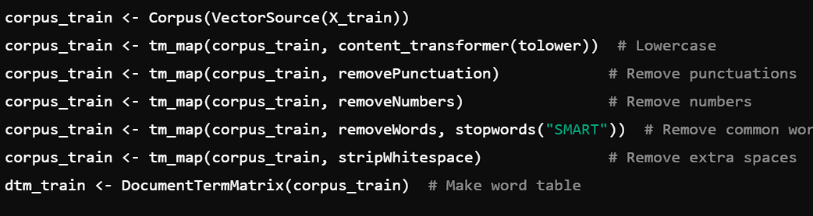

Removing the Rare words:

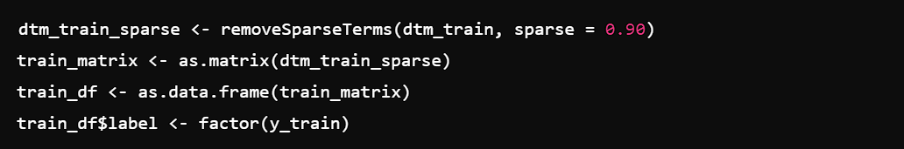

Aligning the Test and Train Data:
- The test DTM (dtm_test) is aligned with the training DTM (dtm_train_sparse) by selecting only the terms that appear in the training DTM (this ensures consistency in terms between training and test data).

- The aligned DTM is then converted to a matrix (test_matrix) and turned into a data frame (test_df)
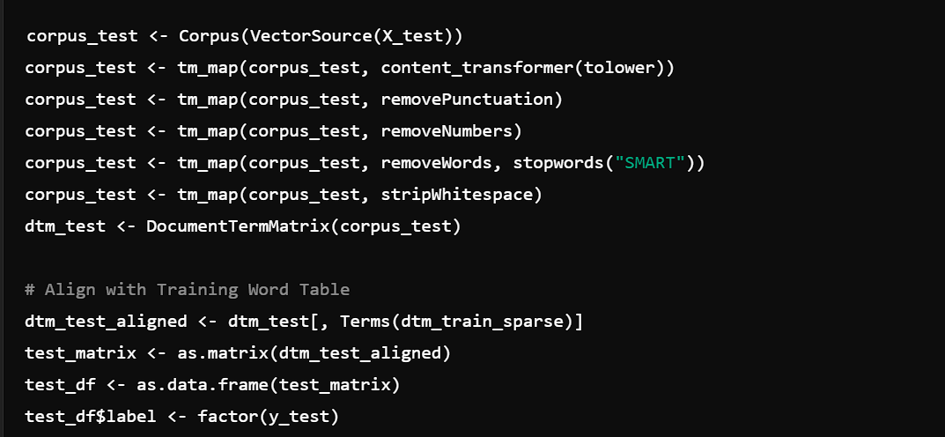
Naïve Bayes Model (Gaussian Distribution):

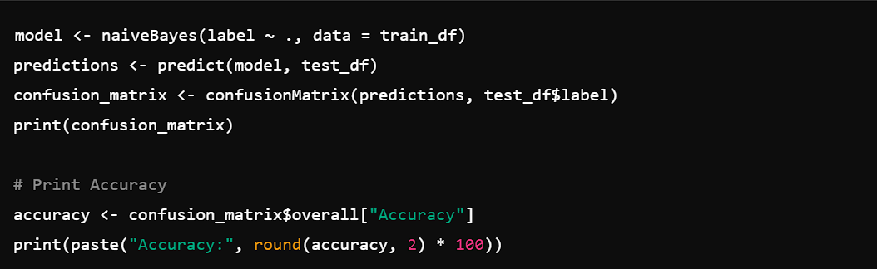

Accuracy: 73%

Confusion Matrix:
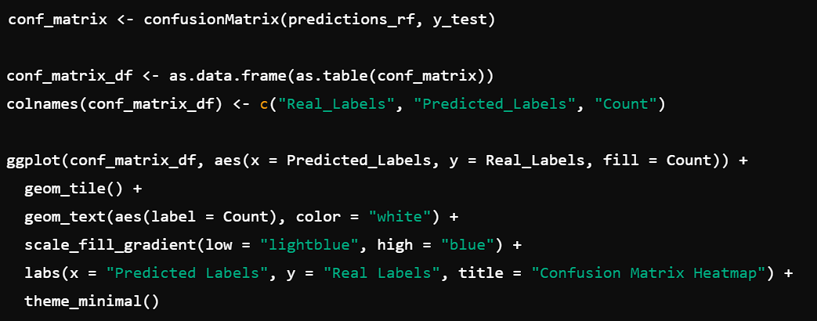
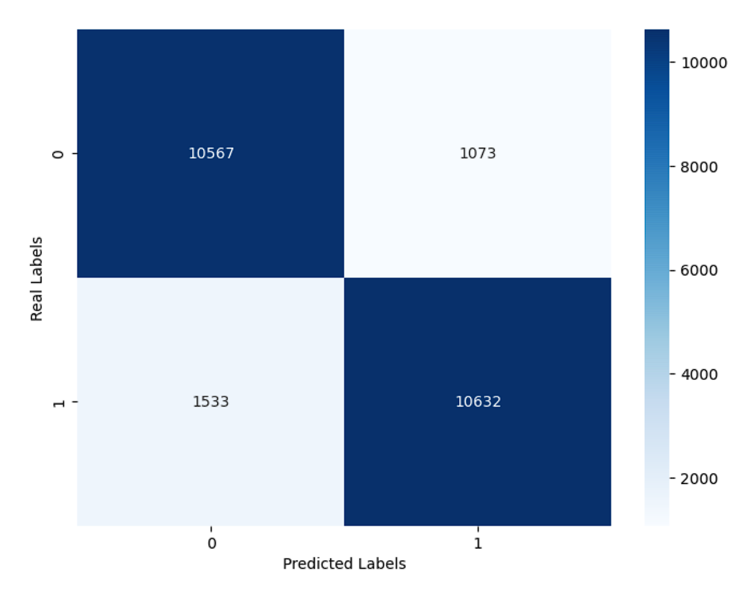

Random Forest Model:

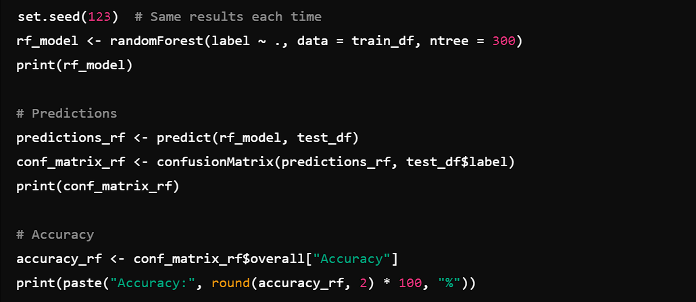

Accuracy: 93%
Confusion Matrix:
